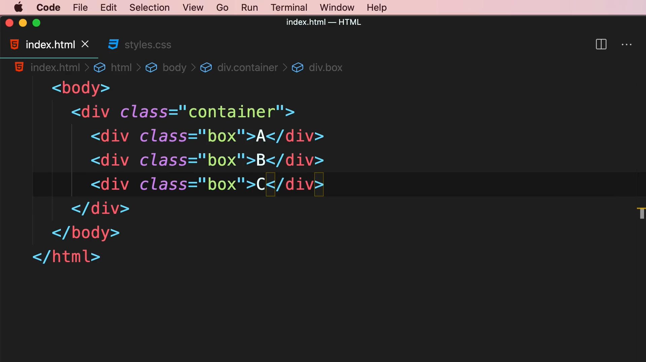

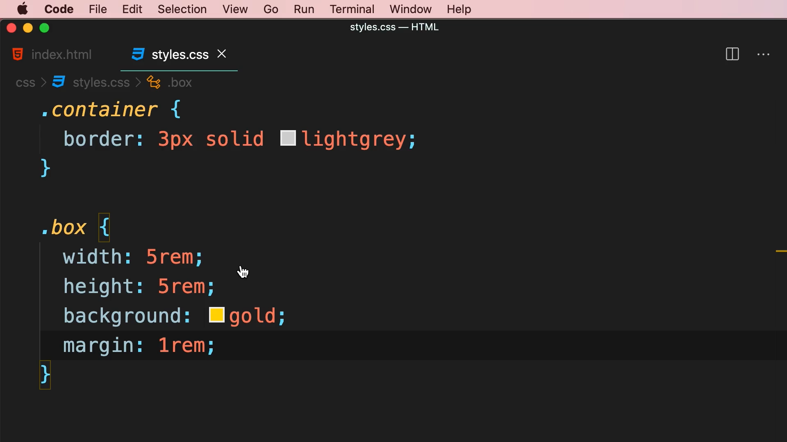

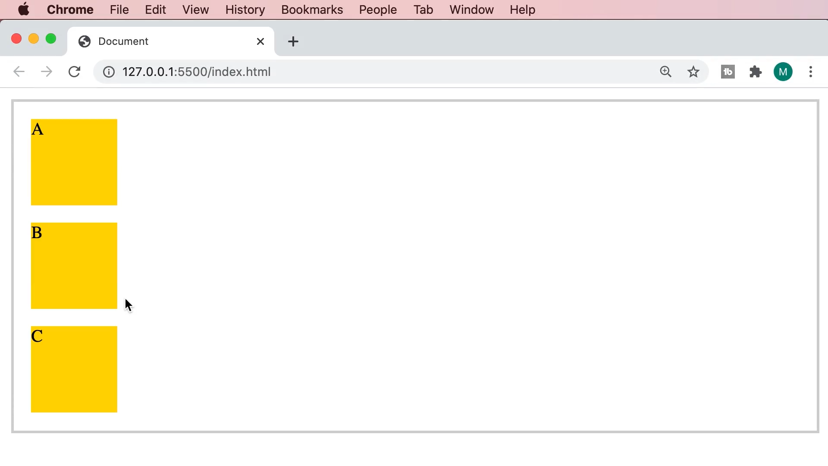

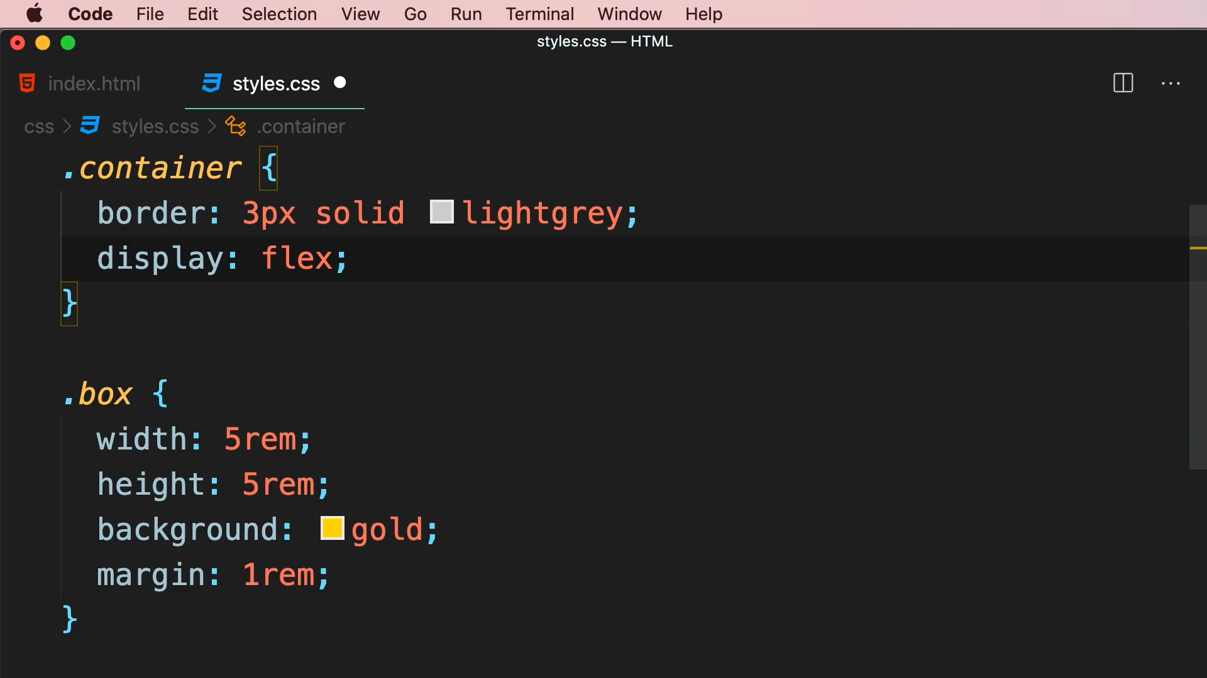

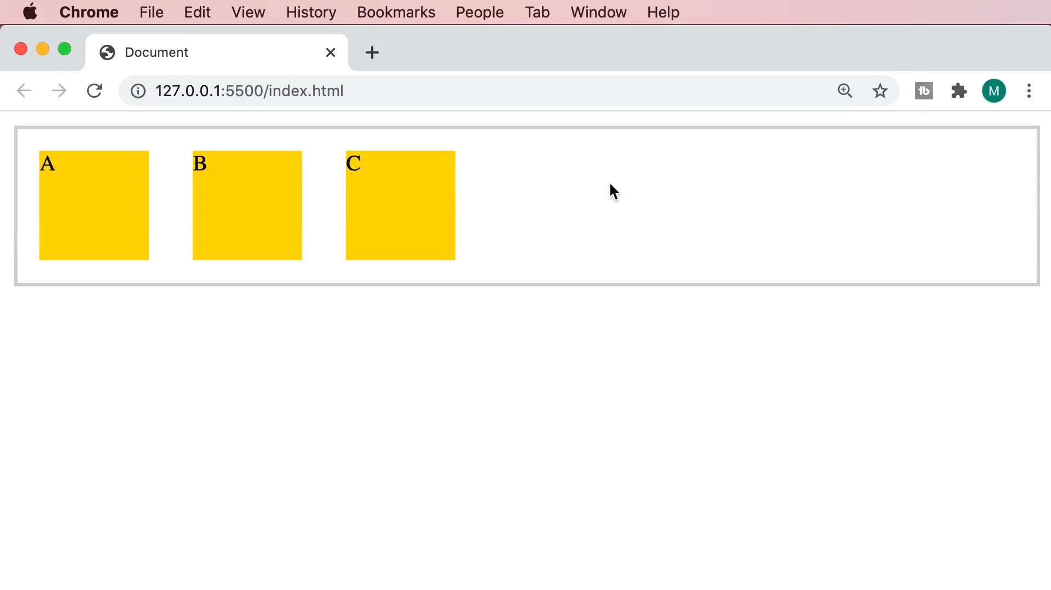

Tailwind CSS

<div class="container flex">

<div class="box">A</div>

<div class="box">B</div>

<div class="box">C</div>

</div>

.container

{

    border: 3px solid lightgrey;

}

.box

{

    width: 5rem;

    height: 5rem;

    background: gold;

    margin: 1rem;

}